GIT INSTALLATION

Git is just like a software which save the changes.

1. For the first time we have to tell the name and your information For that we use

“ $ git config --global user.name <enter the user name 1>”

1. Now we change the configuration and write in such a way that they can know who changes it. By

“$ git config --global user.email <enter the user 2>”

1. To know it is changed nor not so first we run

“ $git config --global user.email”

then we got ‘< user name 2>’ And when we run

“$ git config --global user.name”

then we got <user name 1>

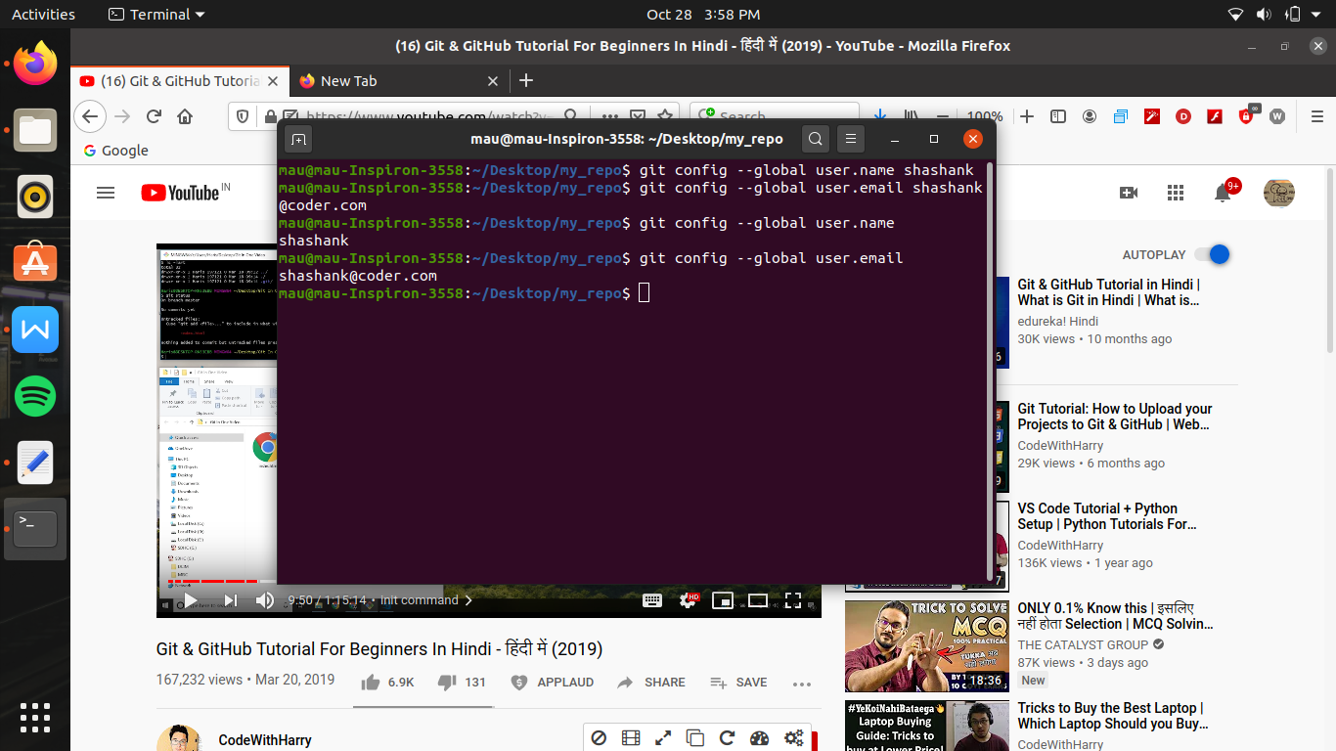

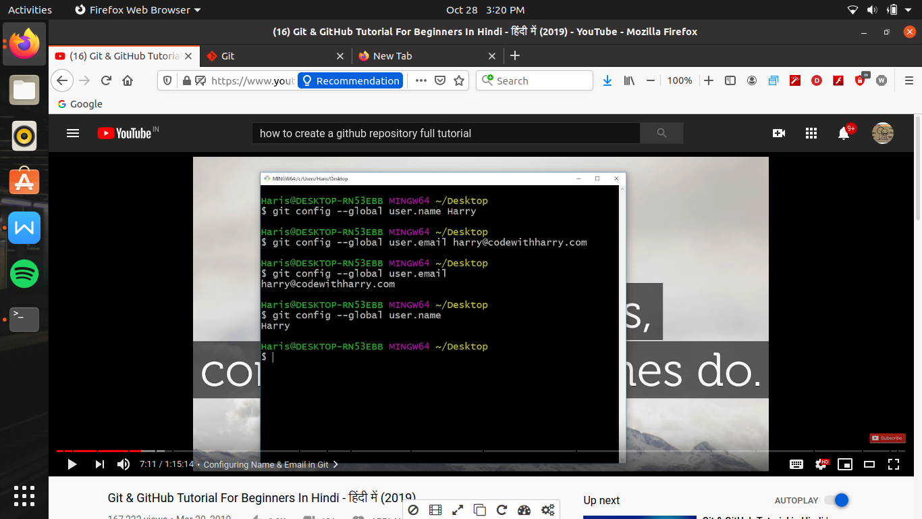

(for to achieve any repo i.e repository either we can use init command or we can do cloning)

( if we do cloning then what happen all the code come from the server)

(and if go for int i.e initialize so on it we start it from the beginning)

1. First we learn about init By

“$ git init”

Now

“$ ls -lart”

this command shows all the hidden folders

Here is a ‘ .git folder’ there all the files are store

Note - for beginner don’t messup with it

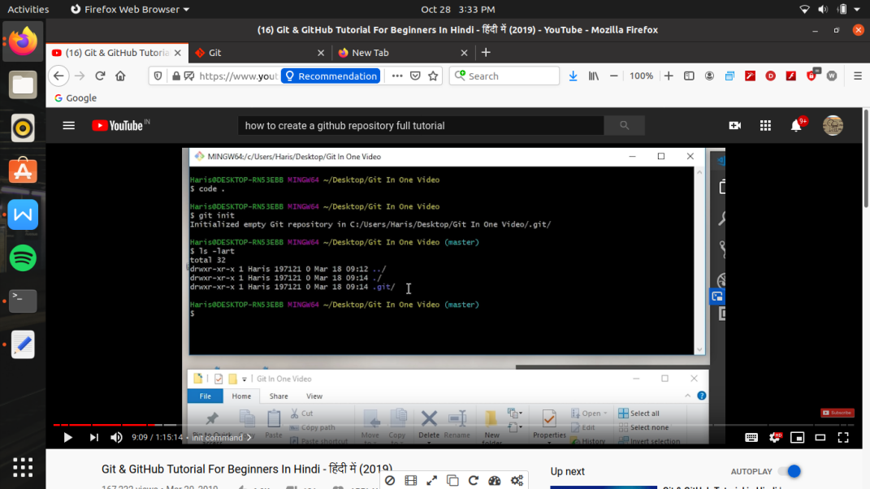

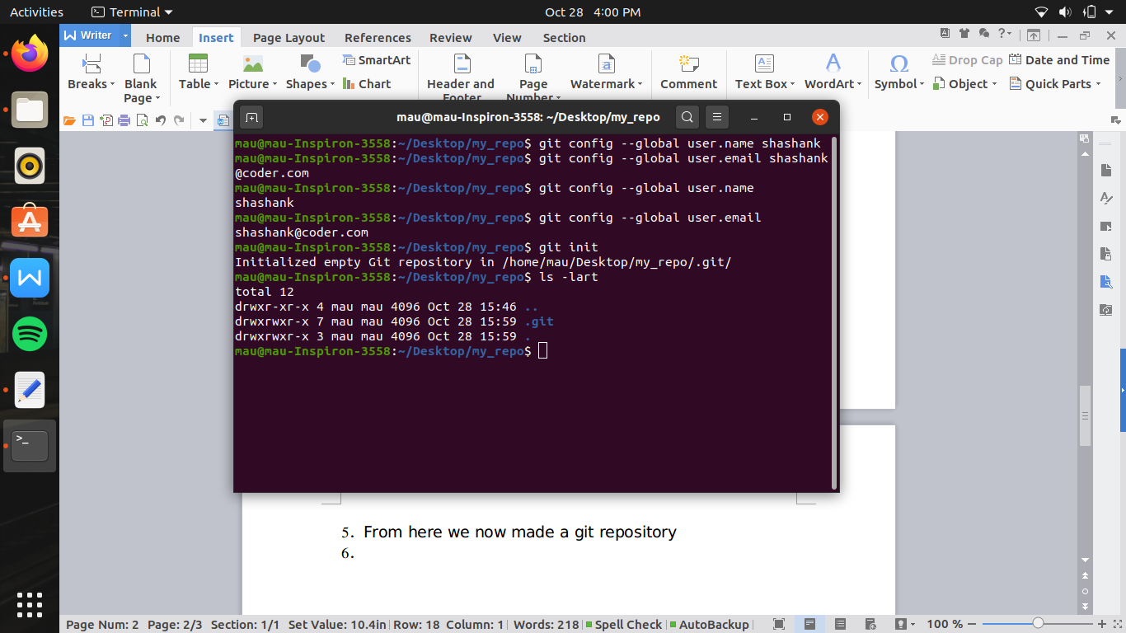

1. From here we now made a git repository

Now by

“$ git status”

we can check the status the the git

6.

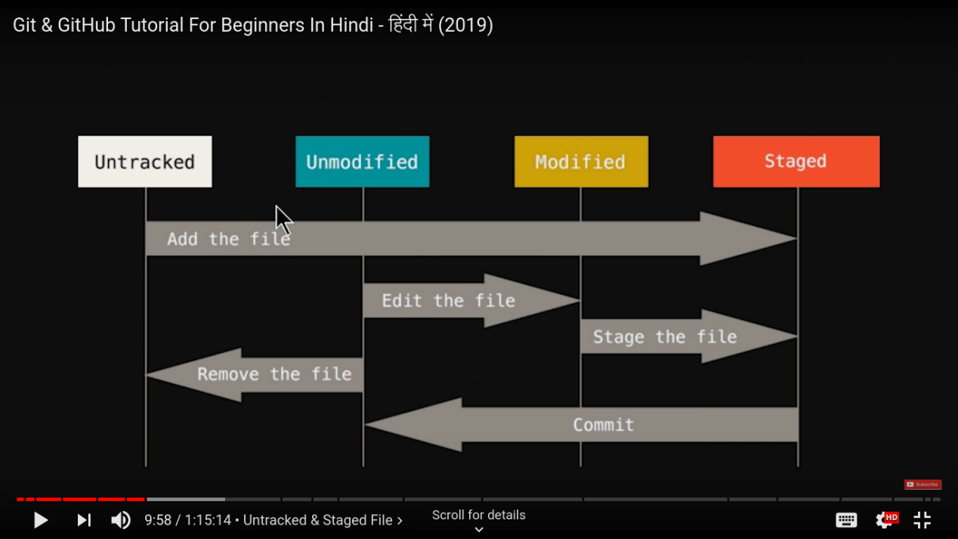

Untracked file - this means with the help of git we are not track the file i.e git es file se matlb hi nhi rakhega

First of all all the files are in the stage in untracked stage.

Now for assigning the task to git for track the file and measure the changes we add the file to staged area

( the file which we do not want to track i.e lock files , binary file , or the files which are generated itself and we don’t care about why these file are generated we only care about source code which we write by ourself)

Staged - in this we add those file which go to commit (i.e those file which we statisfied for the work on it) those file which we which that we need more improvement so we don’t commit that file

(for ex. We made 3 files a.html , b.html , c.html , here we satisfy the work of a.html and b.html so we commit it but we confuse and want improvement so we don’t commit that file)

If we diretly commit the file it will be probramatic of git gave us the option to first , staged the file and then measure or track the file then commit

After commit file goes to unmodified i.e git now record the file

now file is in unmodified stage , from here we can remove the file for let git to not tracked the file

Or we edit the file -- the file becomes modified -- from here we can staged the file and then commit the modified file to unmodified file.

In modified stage git says that you modified the file now you staged the file then commmit it .so that the changes in the file will save

1. Now after adding a file when we check the status of the file by

“ $ git status”

Then the file says initially untracked file

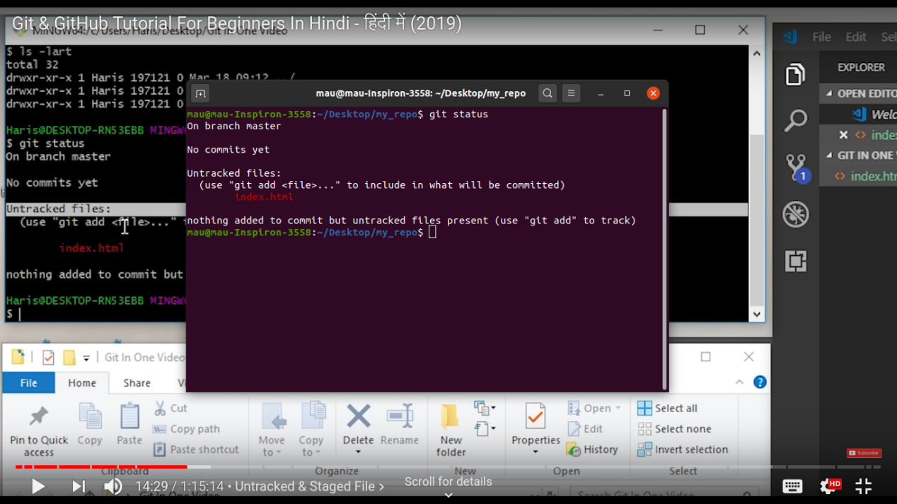

1. For adding a untracked file to - “ $ git add <file name. Extension>